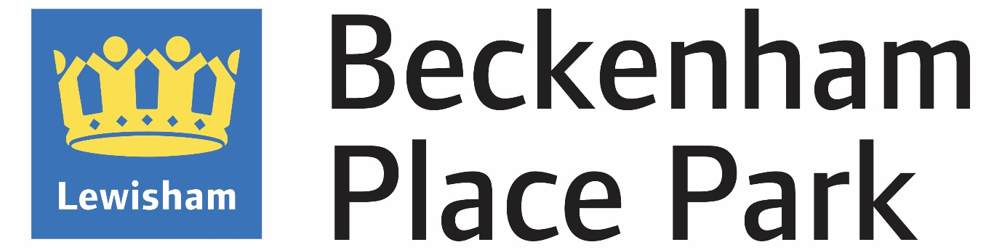

Holding an event in BPP
This guide is relevant to both outdoor and indoor events and provides an overview of what it is like to host an event in BPP and considerations when applying to hold an event here

About Beckenham Place Park
Beckenham Place Park (BPP) is a large outdoor venue in south Lewisham boarding Bromley. With a total area of 96 hectares, it is a a metropolitan protected area with ancient woodland and rich biodiversity. BPP is both a community asset and a destination for visitors travelling from further afield, attracted by BPP’s beauty, the varied programme of events and the facilities available.
Once past one of its 10 gates, visitors gain a sense that they are in a rural landscape, with no buildings on view, although the park itself is well served by public transport.
A railway bisects the park. To the West there is a well-connected landscaped area, with heritage buildings. The visitor hub around the Homestead and Mansion offer plentiful facilities and events throughout the year.
The area to the east side is currently under renovation to bring new features and under management by a contractor, Glendale.

Event areas
The event areas map shows the main event areas for ease of reference. The ‘licensed areas’ give an indication of where licensed activities have been given permission in the past. Event organisers will have to secure their own license, if applicable.
Event area map
When completing the online application, event organisers can pin the event location on a google enabled map. They will still need to attach a site map at the end of the application in the documents section.
Lighting for night time events need to consider conservation. For example, no lighting up trees.

Type of events
At BPP we are conscious of protecting the sanctity of the natural landscape which so benefits the local area and attracts visitors from all over London and the Southeast. As a diverse borough, Lewisham Council, also aims to offer a variety of events catering to different groups.
There is limited opportunity for major events in BPP. Most events hosted in BPP are small to medium sized. The venue is particularly suited to cultural events, markets and food or wellbeing festivals.
It is also the perfect venue for corporate events, with both secluded and accessible areas available with beautiful backdrops.
Community events and initiatives are encouraged, as are sports events.

Licensable activities
Whilst BPP are the landowner and its permission is required to run events in BPP, event organisers are responsible for applying for their own license. Please contact the licensing department. Other charges may apply.
If a license is not required, but there is background music, a noise management questionnaire will need to be completed.
Food & Drink
The park has two resident café bars serving food and beverage. Surplus food and drinks provision outdoors is limited.
In the event of food/drink stalls being part of the event, details for each trader will need to be provided to the environmental health department.
Travel
Event organisers should promote sustainable means of transport where possible and provide appropriate signage and stewarding. Please use this link for details.

Access
Vehicle access is via Beckenham Hill Road gate.
No vehicles authorised on the grass.

Considerations
Practical aspects to consider in your application:
- Is the event a good fit for BPP?
- A well considered, safe event, including first aid provision, ingress and egress
- Appropriate resourcing, including stewards at the events and main gates as appropriate
- Consideration for local residents – noise, car parking
- Is it attracting an audience likely to drive to the park, and if so what mitigation measures can you put on place?
When accessing applications, LBL officers also take into consideration the impact the event may have on other park users and the resident businesses.
Some events need to go to the ESAG and may require consultation or notices put up in the park.

Social Value
BPP seek to encourage all partners to contribute in other ways to the local community, this might include recruiting locally, paying the London Minimum Living Wage, being welcoming and inclusive, practicing fair prices.

What is required of the organiser
It is the organiser’s responsibility, to ensure adequate provision of public toilets/ portals at the event. BPP has a small number of public toilets, and you must take into careful consideration how many toilets you will need, based upon how many people there will be attending your event.

See guide for guidance

Application Timeline
Please note there are minimum lead times to consider. The larger and/or more complex the event, the more time is required to appraise applications. Smaller events still require a minimum lead time. Click here for details

Charges
All applications are subject to a non-refundable application fee that will be charged whether your event goes ahead or not. The price of the application fee varies depending on the size of the event.
These fees are detailed in the Event App page. Other park hire fees apply. A full quote will be given upon assessment of the application.

Document checklist
At a minimum, all events organisers should upload the following in the latter section of the online application form:
Site plan

Risk assessment

Proof of PLI (public liability insurance, min £5 million)

Method Statement or Event Management Plan

Larger events may have other requirements, such as Travel Management Plan and Noise Management plan.
Contact
If any questions not covered in this guide please contact beckenhamplacepark@lewisham.gov.uk

