PUBLIC NOTICE
Name of the event
Will be taking place in
Name of Park
on
Date of event (or range)

This event has been authorised by Islington Council. The event area will not be available for normal recreational use for this time period.

Event set up starts: xx/xx/xx xx:xx
Date and time event starts: xx/xx/xx xx:xx
Date and time event ends: xx/xx/xx xx:xx
Park available again: xx/xx/xx xx:xx

Contact for event organiser: xxxxx xxx xxx
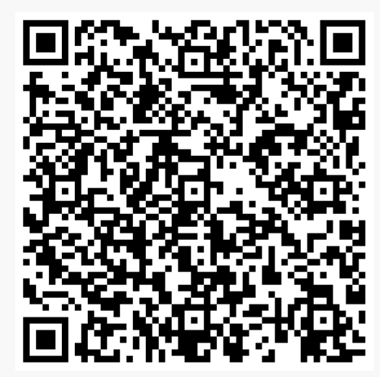
Anti-social behaviour reporting (24/7)
Call: 020 7527 7272 or Scan QR code for online form
Guidance notes for use of this template

This notice is to advise the general public of an upcoming event in their local park. All events have the potential to cause a disturbance to local residents and park users. Advance notice allows park users and residents to alter their normal routines if necessary.

Please print each notice on white paper with black font at A4 size, laminate them and attach them to park railings at least 7 days before your event start date. You should print enough to put up near the entrances/exits and wherever park users congregate (e.g. playground, water fountain, toilet). Some notices will no doubt be removed or will fall off so you will need to check and replace them as necessary.

If your event involves amplified music, performances or voices you will need to provide the start and end times and must schedule in short intervals throughout the event programme. Please be aware that local residents may be looking forward to the breaks between performances so it is important to stick to the times advertised to avoid complaints.

All notices must be removed at the end of your event as part of your waste management removal plan along with any advertising, bunting etc.

