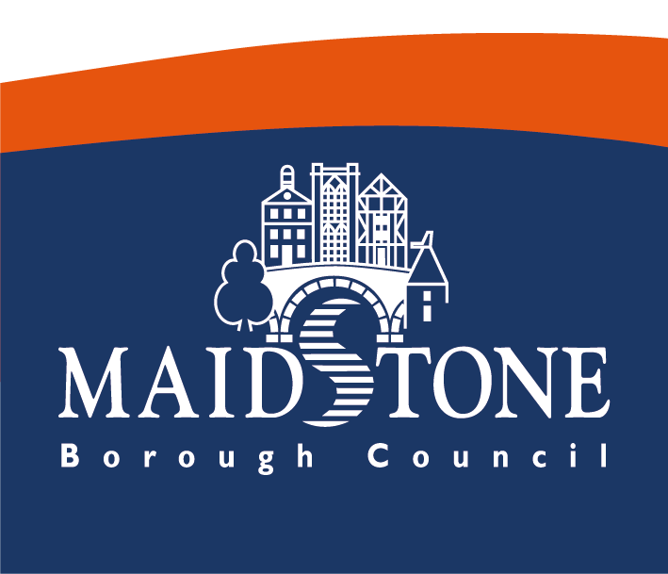

Maidstone Safety Advisory Group

FAQs

Frequently Asked Questions

- What is the purpose of the Safety Advisory Group (SAG)?

- SAGs provide a forum for discussing and advising on public safety at an event. They aim to help organisers with the planning, and management of an event and to encourage cooperation and coordination between all relevant agencies. They are non-statutory bodies and so do not have legal powers or responsibilities, and are not empowered to approve or prohibit events from taking place. Event organisers and others involved in the running of an event, retain the principal legal duties for ensuring public safety.

On the rare occasion where there is disagreement between SAG and the event organiser, and there remains a genuine risk to the public, individual organisations on the SAG such as the police, may decide to act to resolve the issue. Decisions on the use of these powers are matters for the relevant authorities to consider, not the SAG and should be discharged separately.

Q. Who is the Safety Advisory Group?
- The Safety Advisory Group comprises of members from a variety of agencies and departments who can give specific advice concerning events.

Our core members are:
- Local Authority (LA) (SAG Chair)
- Licensing Officer (LA)
- Building Control (LA)
- Food & Safety (LA)
- Community Protection (LA)
- Street Scene (LA)
- Kent County Council Highways and Transportation
- Kent Police
- Kent Fire and Rescue Service
- South East Coast Ambulance Service (SECAMB)
- Maidstone & Tunbridge Wells NHS
- Kent Resilience Team

We may invite other agencies where appropriate.

- What is the benefit of engaging with the Safety Advisory Group?

- By engaging with the Safety Advisory Group process and submitting your event safety plans for review, you have free of charge access to a wealth of expertise and advice to help you plan comprehensively.
Some insurance companies or governing bodies such as the Civil Aviation Authority require event organisers to engage with the local Safety Advisory Group in each district that an event is held in.

- What do I do when a member of SAG makes a recommendation for changes to my plans?

- All feedback is advisory and it’s the event organisers discretion as to whether they follow it. It is recommended that your plans and practices are updated in accordance with the feedback provided and re-circulated to the SAG for their information.

If there were to be an incident at your event and the safety plans & processes were scrutinised, it may not be viewed upon favourably by a court if advice from the SAG was ignored.

- How do I find out whether my event needs to be notified to SAG?

- The Safety Advisory Group will never turn a notification away, but if you are unsure whether you need to notify us, please contact us using the details at the bottom of the FAQ.

- Are all SAGs the same across the country?

- No, they’re not all the same but the principal of their existence is the same.
Other SAGs may have additional members from other appropriate agencies such as river authorities etc. and each SAG will have their own notification process & timescales.
Get in touch with them nice and early to ensure you give yourself plenty of time to engage with their process.

- Where can I get event planning guidance?

- You can get a multitude of information from The Purple Guide and the HSE.

Maidstone Safety Advisor Group have some guidance available through our EventApp portal. Visit https://www.maidstone.gov.uk/home/other-services/events/tier-2-primary-areas/event-planning for more information.

To access information from certain sources, you will need to purchase a subscription. The Purple Guide is £25.00 + VAT for a 12 month subscription. Visit https://www.thepurpleguide.co.uk/ for more information.

Advice specifically in respect of Sports Safety Grounds can be found in a document commonly referred to as the Green Guide but is officially called the Guide to Safety at Sports Grounds. A hard copy or a digital copy can be purchased for £95 each or both for £150.00. Visit https://sgsa.org.uk/greenguide/ for more information.

*Prices correct as of 15th January 2020.

- How much notice do I need to give SAG?

- Please refer to these timescales as a guide:

- Events for up to 5000 attendees require a minimum of 3-6 months notification.
- Events for 5000-9999 attendees require between 6-9 months notification.
- Events for more than 10,000 attendees require between 9-12 months notification.

  - Must I notify the SAG if I only wish to apply for a road closure under the Town Police Clauses Act 1847?

- Maidstone Borough Council’s application for a road closure is now automatically taken through the SAG process as a best practice measure.

Requests to close a road are usually received because an event is taking place on a public highway or a number of pedestrians will be on the highway for an extended period of time and therefore we want to ensure the safety of both road users and pedestrians has been considered fully when reviewing the request.

The Safety Advisory Group will review all aspects of the event plans but as the event organiser you will not need to notify the blue light agencies or KCC Highways separately about your road closure. This is all done for you within the notification process.

For further queries please contact safetyadvisorygroup@maidstone.gov.uk.

