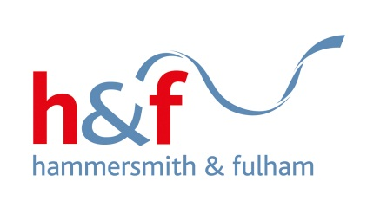

Filming in Hammersmith and Fulham – Covid-19 Guide Lines (June 2020)

Filmmakers Filming in and around the London Borough of Hammersmith and Fulham are expected to protect the public by making sure that any crew and cast are kept separate from the general public by creating an Exclusion Zone using physical barriers and signage, in parks and open spaces and on pavements and walkways where appropriate. Public should be made aware that they are not to enter the Exclusion Zone.

On pavements and walkways, where it is not possible or inappropriate to create an Exclusion Zone, there must be sufficient space for the general public to pass. It is vital that any plans for diverting the public must not cause issues elsewhere; e.g. on the opposite footway where it may cause overcrowding and be harder to maintain social distancing than the original route.

Filmmakers must demonstrate that they have planned for social distancing measures that comply with the current guidelines (2 m), and that they understand their responsibilities to their cast, crew and to the public under Health and Safety legislation.

Guide Lines from the British Film Commission can be found here:

http://britishfilmcommission.org.uk/guidance/regarding-covid-19-coronavirus/

Guidelines from Film London can be found here:

http://core.filmlondon.org.uk/library/documents/COVID-19GuidanceforLocationFilming.pdf

Filmmakers must also demonstrate that they are working to the Film London Code of Practice:

http://core.filmlondon.org.uk/library/documents/FLCODE1.pdf

Applicants for film permits must supply the following documents to a completed online application form available at
https://app.apply4.com/filmapp/uk/lbhf

- A signed copy of this document.
- A copy of the method statement from the production Health and Safety Supervisor, specifically addressing the mitigation measures taken to reduce any Covid-19 related risks (See British Film Commission Guide Lines).
- Public Liability Insurance
- Diagrams of all proposed locations showing how the Exclusion Zone / Social Distancing will operate.

Before the shoot, film companies will present detailed plans which show exactly how they will maintain the Exclusion Zone / Social Distancing plans.

On the morning of the shoot, the location department must send photographs of the signage and barriers in place to filmoffice@lbhf.gov.uk
All must conform to the approved Exclusion Zone / Social Distancing plans.

Signed | Print Name
Production Company | Date(s) of filming

