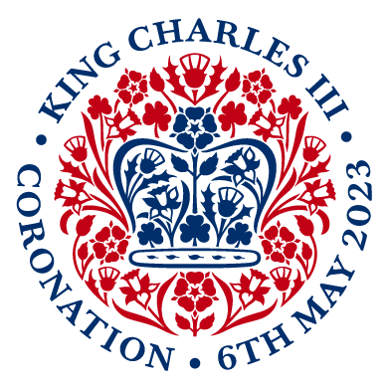

Application for Temporary Street Closure
and Parking Suspensions for Coronation Street Parties 2023

Please complete and return this form to specialevents@rbkc.gov.uk

Event Organiser Name

Company (if applicable)

Address

Contact Telephone Number

Email Address
Event Name

Event Date

EventApp Reference Number
Your online application reference

Road closure details
Please list all streets affected, including house number or junction to help identify the start and end of the closure area if the whole street is not affected.

*A sketch plan is required to be submitted to accompany this form.

Road closure timings
Eg from 0800 to 1600
The street must be completely clear by the time the road is to be reopened to traffic, so please include clear-up time.

Parking Suspensions required |  | (yes/no)
 |  | Please detail below.
Date & Time parking suspension required  Refer to parking suspension times explained below | Number & Type of parking bays required  Specify the type of bay eg pay & display (P&D) resident, car club, single yellow line | Road name  Please include the full address of parking bay(s) including house number and machine number if P&D | Description  Please describe the location of the parking bay(s) | KES Ref  For parking office use only
Example:  (DATE)  0830 - 1830 | Example:  2x P&D bays | Example:  24-26 Portobello Road  P&D Number: 324 | Example: North side of road, outside of number 24 next to post box

Total

Parking Requirements Notes

- Provide road name(s), precise locations, number of bays required and P&D machine number if you are suspending P&D bays.
- Indicate whether the type of bay requested is a Pay and Display (P&D), Resident Parking bay, Disabled bay or Car Club bay. Use P&D bays where possible as Resident Parking bays, Disabled and Car Club bays will only be suspended in exceptional circumstances.

- Resident bay suspensions require 14 working days’ notice and Pay and Display bays require 7 working days’ notice.

- We are unable to provide suspensions for electric vehicle charging bays.

- Please don’t remove our parking signs from the lamp posts, our parking department will take these down once the suspension time ceases. If you finish using the bays before the suspension time, please contact the Borough’s Event Officer.

- Please don’t put cones in the bay before the suspension time, as your cones will be removed by our Street Enforcement Team.

IF THERE IS A PROBLEM WITH ANY VEHICLES PARKED ON YOUR SUSPENDED BAYS, PLEASE CALL NSL FOR ASSISTANCE WITH RELOCATING THE VEHICLE ON 01285 238 956 OR FAX 020 7352 0528

